

Practices for Secure Software Report

Table of Contents
Document Revision History 3
Client 3
Instructions 3
Developer 4
1. Algorithm Cipher 4
2. Certificate Generation 4
3. Deploy Cipher 4
4. Secure Communications 4
5. Secondary Testing 4
6. Functional Testing 4
7. Summary 4
8. Industry Standard Best Practices 4

Document Revision History

Version | Date | Author | Comments
1.0 | 10/21/2026 | Maria Flores

Client



Developer
Maria Flores

Algorithm Cipher

I recommend Advanced Encryption Standard with a 256-bit key in Galois/Counter Mode (AES-256-GCM) to protect the confidential information at rest. AES is a symmetric block cipher which is the same secret key that encrypts and decrypts data. GCM adds authenticated encryption, provides confidentiality and an integrity check through an authentication tag.
AES operates on a 128-bit block and supports 128-, 192-, and 256-bit keys. A 256-bit key provides a large key space against brute-force attacks. For each AES-GCM encryption operation, the application must use a unique nonce (usually 96 bits) and a crypto-graphically secure random number generator. Reusing a nonce with the same key can seriously compromise security. Encryption keys should be stored and rotated securely and separate from the encrypted data.
Symmetric encryption is efficient for large files and records, whereas asymmetric cryptography uses a public/private key pair and is commonly used for identity verification, digital signatures, and establishing secure session keys. The application uses a self-signed certificate for local HTTPS testing. A certificate trusted by the client system should be used for production. This would be my recommendation for the future as AES was not implemented for the checksum endpoint.
Hashing is different from encryption. The implemented SHA-256 function produces a 256-bit (32-byte) digest which is represented as 64 hexadecimal characters. A hash cannot be decrypted and it supports integrity checking by comparing a newly calculated digest with a trusted expected digest. The current /hash demonstration calculates and displays a digest but does not compare it against a separately trusted reference value or authenticate the file source.
Historically, encryption evolved from manual substitution ciphers to DES, which became inadequate as computing power increased, and then to AES which was selected as a U.S. federal standard in 2001. Modern practice favors authenticated encryption such as AES-GCM, modern TLS for transport, and SHA-256 or stronger hash functions for security sensitive integrity checks.

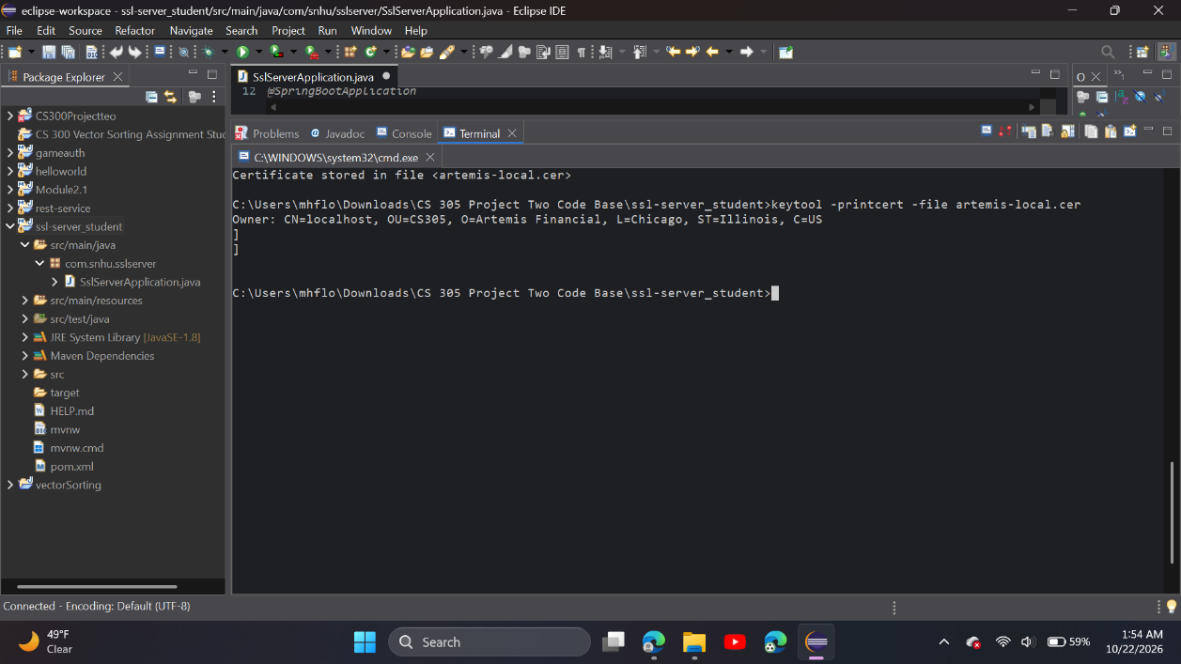
Certificate Generation: Screenshot of CER file.

Deploy Cipher: Screenshot of checksum verification.
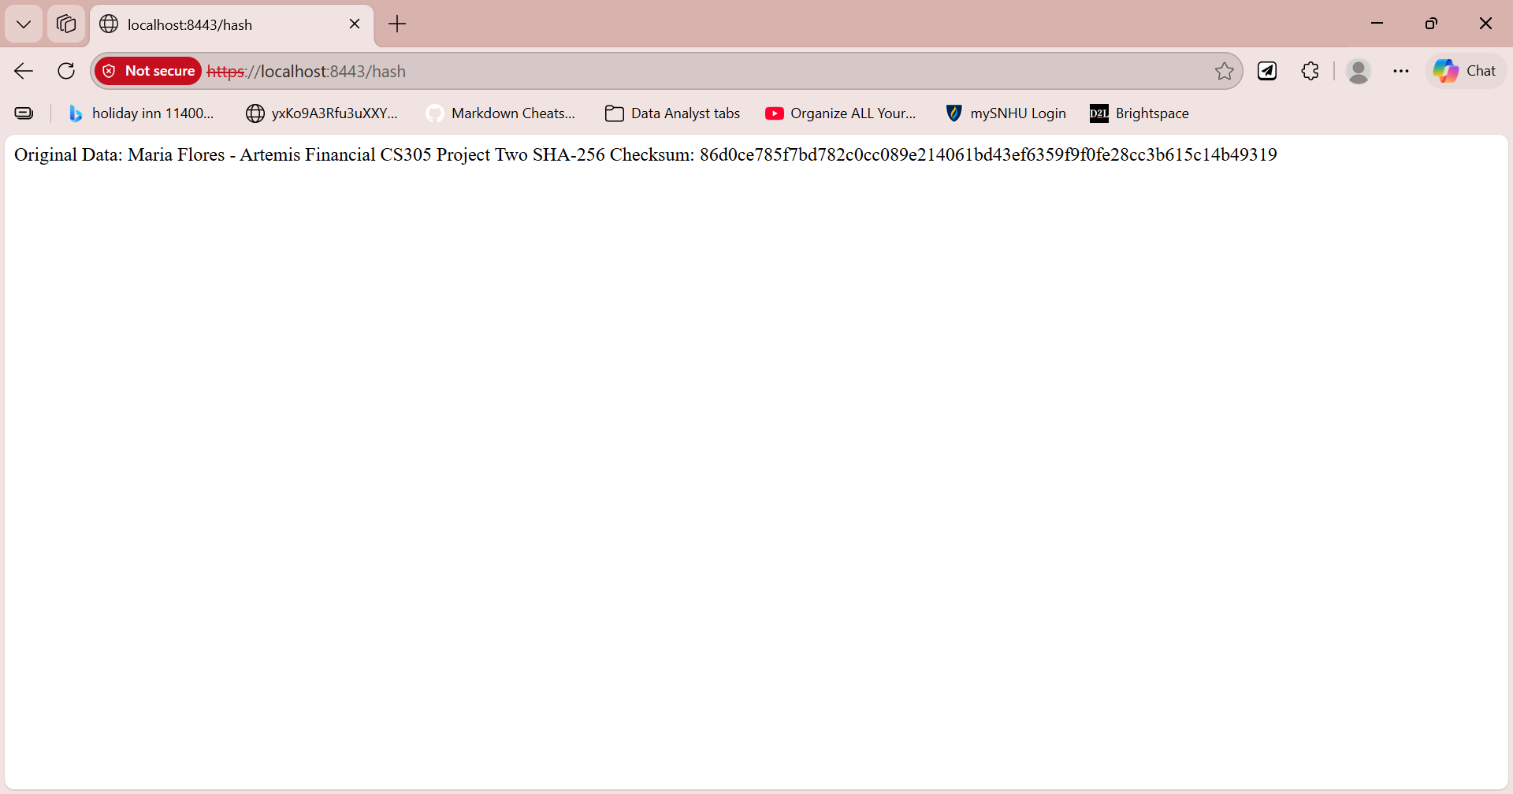

Secure Communications
Screenshot of web browser that shows a secure webpage.
The HTTPS endpoint responds at https://localhost:8443/hash. The browser marks the self-signed certificate as untrusted. This is expected in local testing, not proof of production trust.
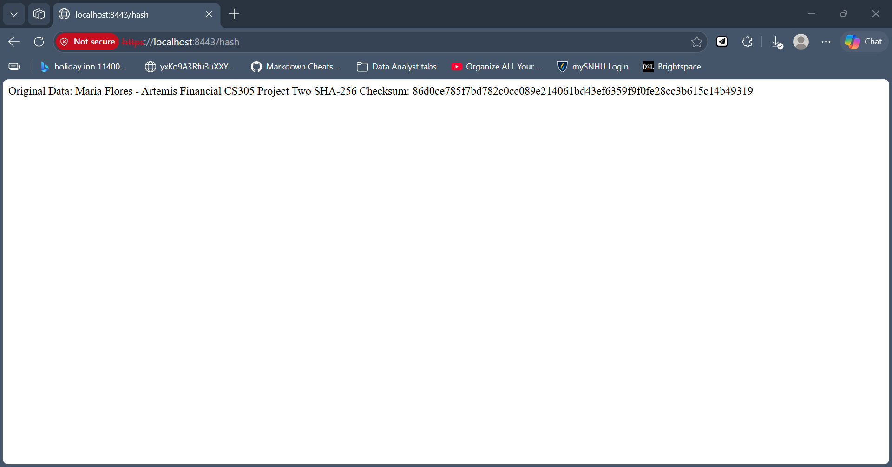

Secondary Testing
Insert screenshots below of the refactored code executed without errors and the dependency-check report.
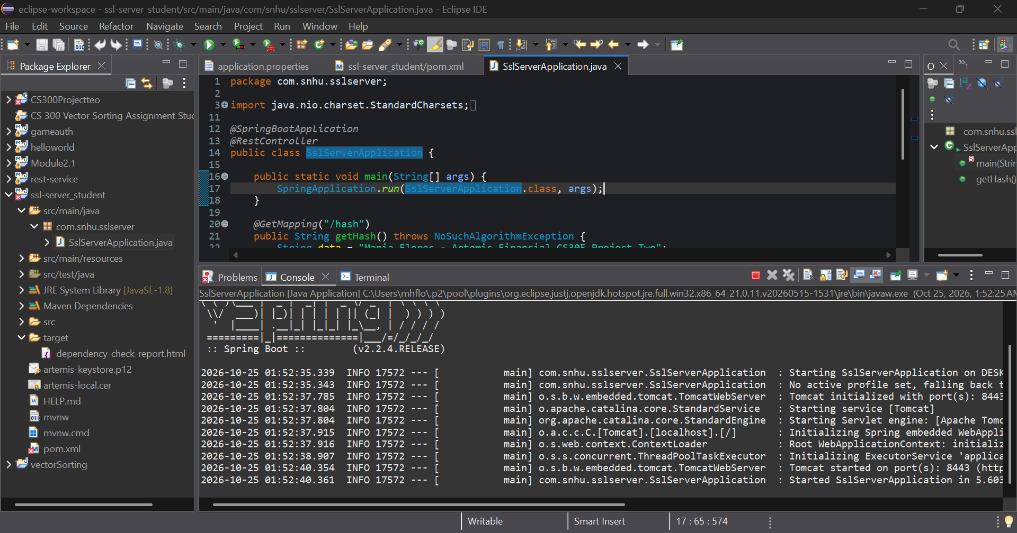
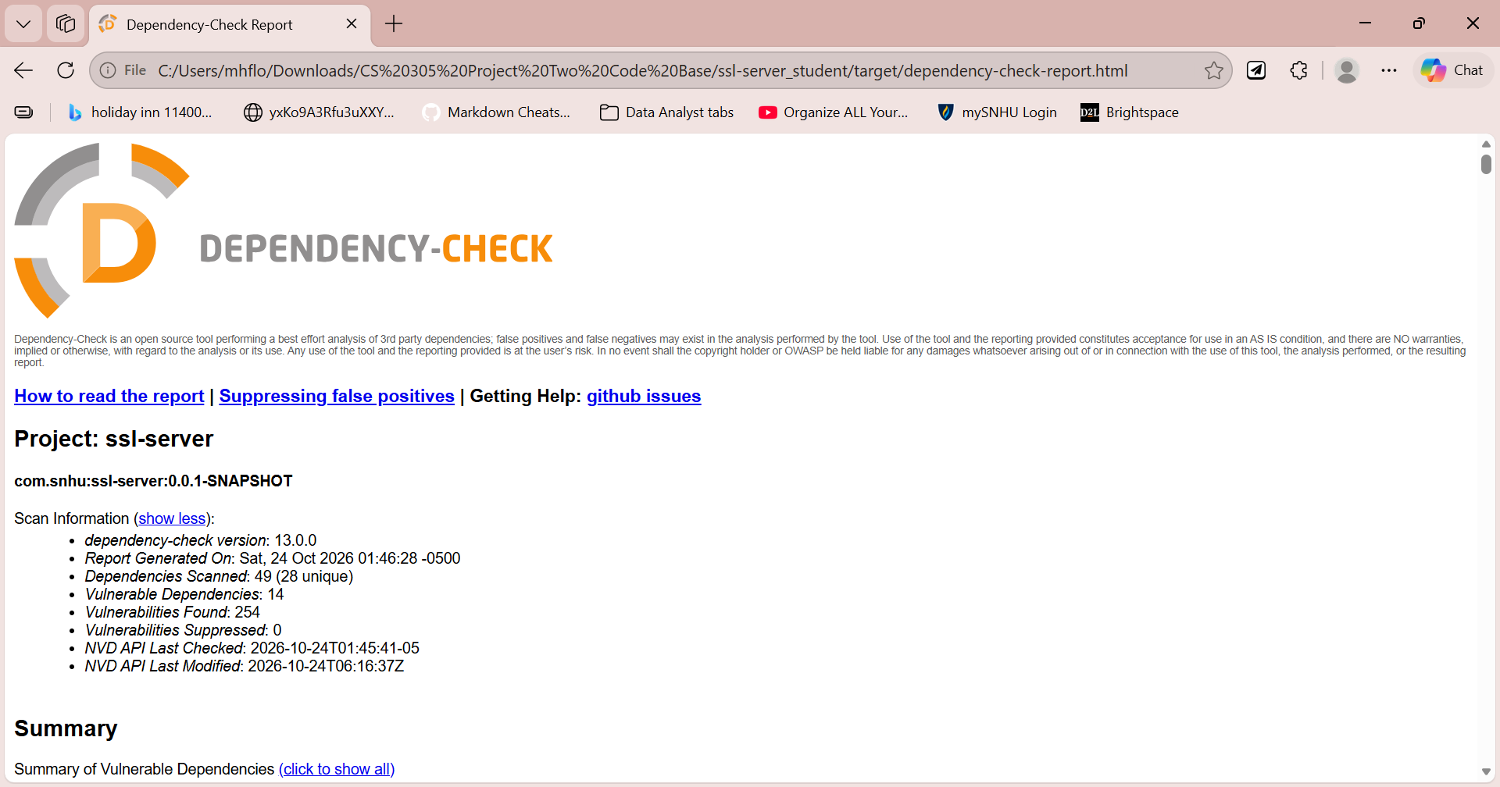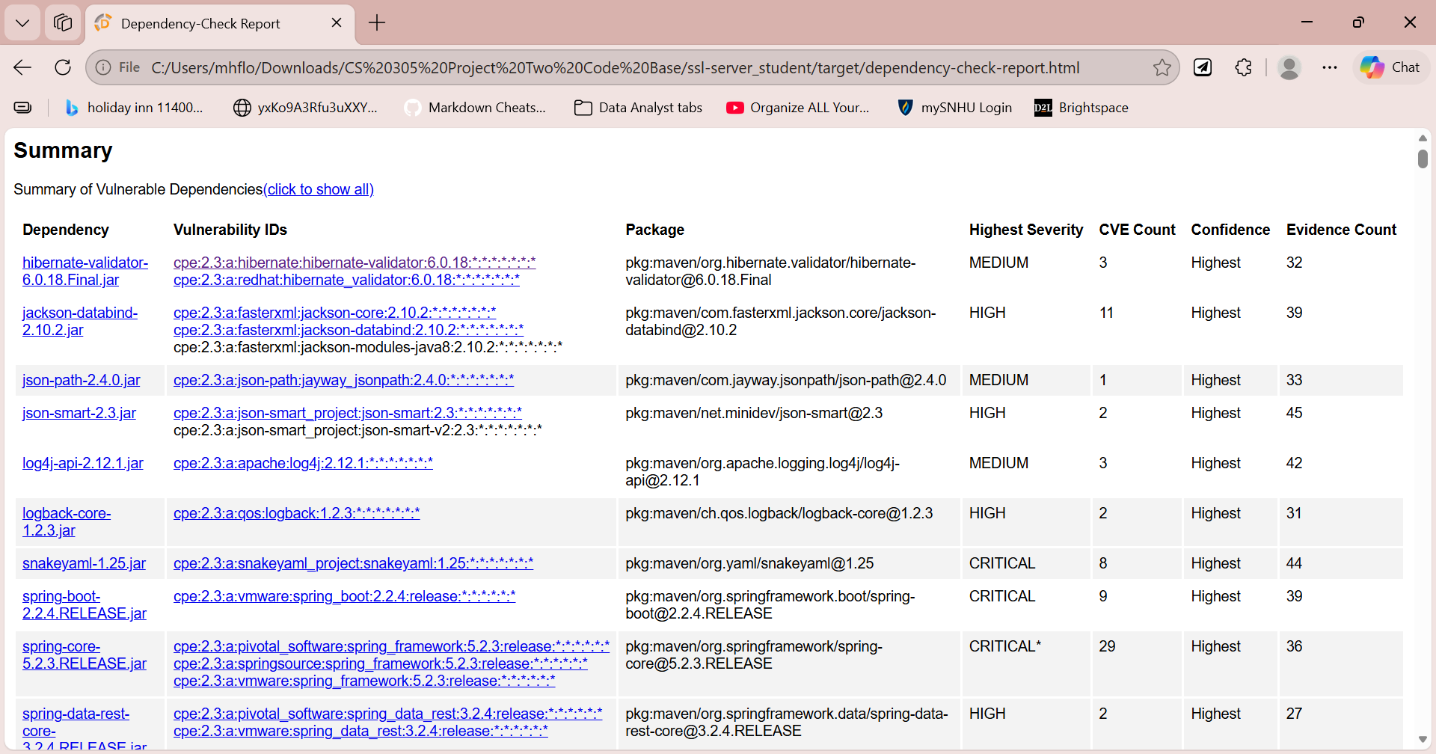

Functional Testing
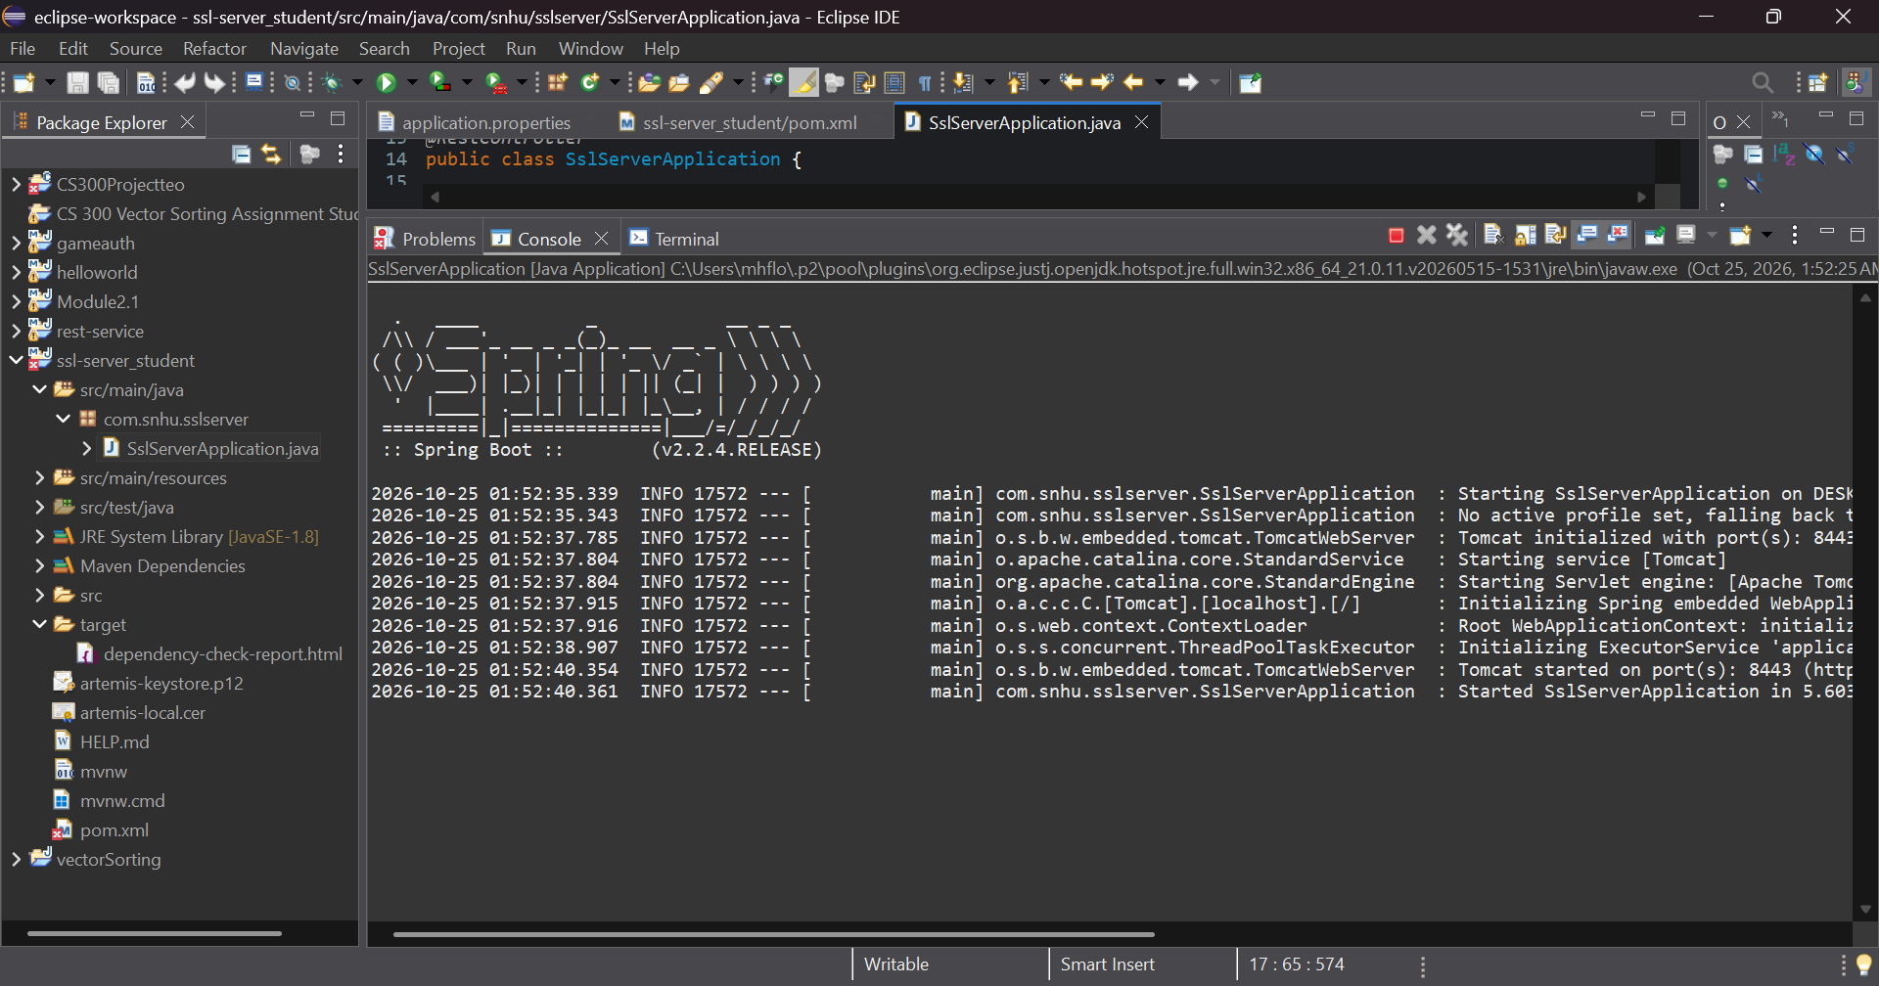

Summary

I reviewed the Artemis Financial Spring Boot REST application and refactored its /hash endpoint to calculate a SHA-256 digest from a unique UTF-8 string identifying the project. I also configured the application for HTTPS on port 8443 with a locally generated self-signed certificate. The browser successfully displayed the original data and the 64-character checksum without an HTTP 500 error. These changes demonstrate data-integrity hashing and encrypted transport in the local environment. The supplied Vulnerability Assessment Process Flow begins with an architecture review and considers input validation, APIs, cryptography, client/server communications, code errors, code quality, and encapsulation. My changes principally address cryptography and client/server communications. I did a manual review of the controller that addresses code errors and code quality. The OWASP Dependency-Check scan provides evidence for the static-analysis stage, followed by manual code review and a mitigation plan.
Defense in depth was applied through a certificate-backed HTTPS configuration, SHA-256 digest generation, manual endpoint testing, and automated third-party dependency analysis. The secondary scan completed successfully with 49 dependencies scanned (28 unique), 14 vulnerable dependencies, 254 reported vulnerability findings, and zero suppressed findings. These findings require investigation and remediation; a successful scan is not equivalent to a vulnerability free application. The older Spring Boot 2.2.4 RELEASE and related dependencies remain important upgrade priorities.
Before production deployment, the team should upgrade to supported dependency versions, rerun dependency analysis, validate certificate trust, manage private keys securely, and implement comparison against a trusted checksum when verifying transferred files.

Industry Standard Best Practices

The refactoring uses Java’s standard MessageDigest API with SHA-256 and explicit UTF-8 encoding, avoiding custom cryptographic implementations and platform-dependent character encoding. The hexadecimal conversion preserves leading zeros so the digest is consistently 64 characters. The endpoint was manually tested in a browser and the dependency tree was scanned with OWASP Dependency-Check 13.0.0. Existing application functionality was retained while the additional security behavior was verified.
Secure coding practice also requires separation of concerns: SHA-256 supports integrity checking, HTTPS protects transport, and encryption such as AES-GCM is appropriate for confidential data at rest. A development self-signed certificate should not be treated as a production trust solution. Private keys and passwords must be protected, and secrets should not be embedded in source control. Automated dependency scanning should remain part of the build and review process.
For Global Rain and Artemis Financial, these practices would reduce the risk of unauthorized disclosure, undetected modification, insecure configuration, and vulnerabilities in third-party libraries. They also support maintainability, customer confidence, regulatory responsibilities, and timely remediation. The application should not be described as production ready until the vulnerabilities identified have been assessed and addressed.

